Teacher Pay Teacher
August – December 2021 =
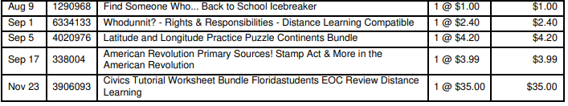
Total = $46.59

January – Present 2022 =
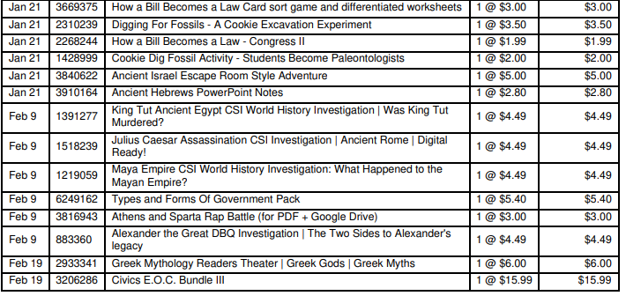
Total - $66.64

Grand Total = $113.23

