Tribal Masks: Adapted from School Specialty Lesson Plan
Lesson Plan, Grades 4-12, Art, Social Studies, Multi-Cultural
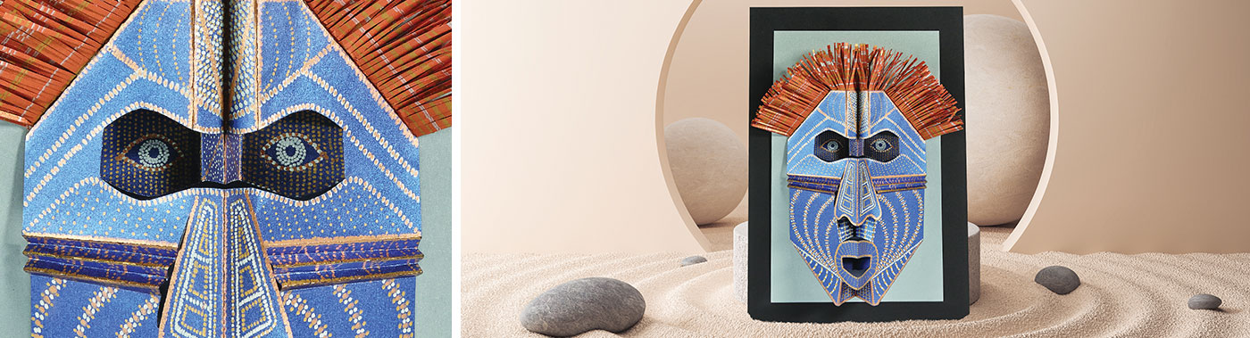
Lesson Plan and Artwork by Carol Miller https://www.schoolspecialty.com/wcsstore/SSICatalogAssetStore/ideas-resources/V2182561.pdf
Tribal Masks have been a part of numerous cultures throughout history. They marked occasions such as religious ceremonies, harvest festivals, rituals, and funerals. This lesson plan includes a template that will aid in experimenting with symmetrical pop-up techniques as applied to decorative mask making.
Learning Goals:
- The student will learn about African Culture and Mask Making
- The student will experiment with symmetrical pop-up techniques, resulting in the creation of a symmetrical tribal-type mask
- The student will embellish the mask with traditional patterns and methods used on African masks
Florida Standards/Benchmarks:
VA.68.H.1.3: | Analyze and describe the significance of artwork from a selected group or culture to explain its importance to the population.
VA.68.S.1.4: | Use accurate art vocabulary to explain the creative and art-making processes.
VA.68.S.1.5: | Explore various subject matter, themes, and historical or cultural events to develop an image that communicates artistic intent.

Materials:
Cardstock or heavy construction paper, assorted markers, scissors, glue, tape, raffia, beads, other recycled materials
Optional Sponsored Material Recommendations (School Specialty):
- Sharpie® Metallic Permanent Markers, Metallic Gold, Fine, Pack of 12
- Sharpie® Metallic Permanent Markers, Metallic Silver, Fine, Pack of 12
- Sharpie® Metallic Permanent Markers, Metallic Bronze, Fine, Pack of 12
- Creative Collection™ Metallic Finish Cardstock, Assorted Dark Colors, Pack of 40 Sheets
- Creative Collection™ Metallic Finish Cardstock, Assorted Light Colors, Pack of 40 Sheets
- Astrobrights® Cardstock, Black, Pack of 100 Sheets
Directions:
- Introduce students to African Masks. Show examples (from bin, from Internet, etc…)
- Look at and/or create a handout with information and visual examples.
- Discuss with students different reasons these masks were made, different uses…ask them to think about what they might make a mask for, what message they would like their mask to present, what their reason or usage could be, perhaps generate a theme.
- Download mask template. Trim the template to 4 1/4" X 11".
- Using practice paper, fold in half, vertically. Place the template on the paper with the fold to the right and transfer by drawing over the black lines with enough pressure to leave an imprint. Cut on the black line impressions, keeping the paper folded.
- Place the template on the folded paper again and transfer the red and blue lines ignoring the lines on the center fold for now. Unfold the mask and using the template’s back-side, do the same on the right side of the mask, drawing on the imprint of the template’s red and blue lines. This will create scoring lines for folding.
- Using the red and blue lines on the template as a guide, fold the red lines, pointed toward you and fold the blue lines, pointed away from you.
- The angled folds on each corner will later provide a surface to affix the finished mask to a mounting and will allow you to determine how wide or narrow it will be.
- The folds along the center fold will define the eyes nose and mouth, by pushing folds inward and outward according to their color.
- The cheek folds add design and also cause the nose to overlap, downward, creating another plane. The edge of a ruler may help in folding these narrow creases. Also, try alternating the folding of each crease from the left and right cheeks, instead of doing all one side at a time.
- Now, decide if you will create your own template, make changes to this one or use the included template.
- Use markers, crayons, oil pastels, construction paper crayons to create patterns on the mask.
- Create hair, beards, earrings, other adornments with additional paper, raffia, yarn, …
- Using glue or double-sided tape to attach pieces. You may wish to use two or three layers to obtain greater bulk.
- Mask could be finished at this point or mounted carefully, onto a separate sheet of cardstock, using glue or double-sided tape on each of the corner folds that are closest to the corner’s edge. Determine the width of the mask and adhere in place.

GRADING RUBRIC:
0 (0 points) | 1 (5 points) | 2 (10 points) | 3 (15 points) | 4 (20 points) | SCALE
No mask was made | Incomplete mask, no successful pop ups | Partial mask, some pop ups evident | Pop up mask completed | Additional elements beyond those required
No craftsmanship, mask falls apart | Parts of the mask stay together | Most of the mask well made, some edges/parts rough | Mask is neatly constructed, all pop ups work | Additional elements beyond those required
No patterns | The beginnings of a pattern | Patterns show in part of mask | There is at least one pattern evident in finished mask | Detailed and creative use of patterns
No additional decorations | One or incomplete additional decoration | Some decorations, but incomplete | Mask has additional themed decorations, completed, besides pop ups | Unique and creative mask with clear theme
No name, title, class, no craftsmanship | Missing title, name, and class, poor craftsmanship | Missing title, name, or class, craftsmanship could be improved | Title, student name, and class on back, good craftsmanship | Unique title, name, class, outstanding craftsmanship
Total Score

Reteach/Enrich:

- Work with a partner/peer tutor
- Break down into smaller steps
- Reduce the elements in the assignment
- Make a smaller version
- Make a second project
- Add additional details to original
- Help another student/peer tutor

