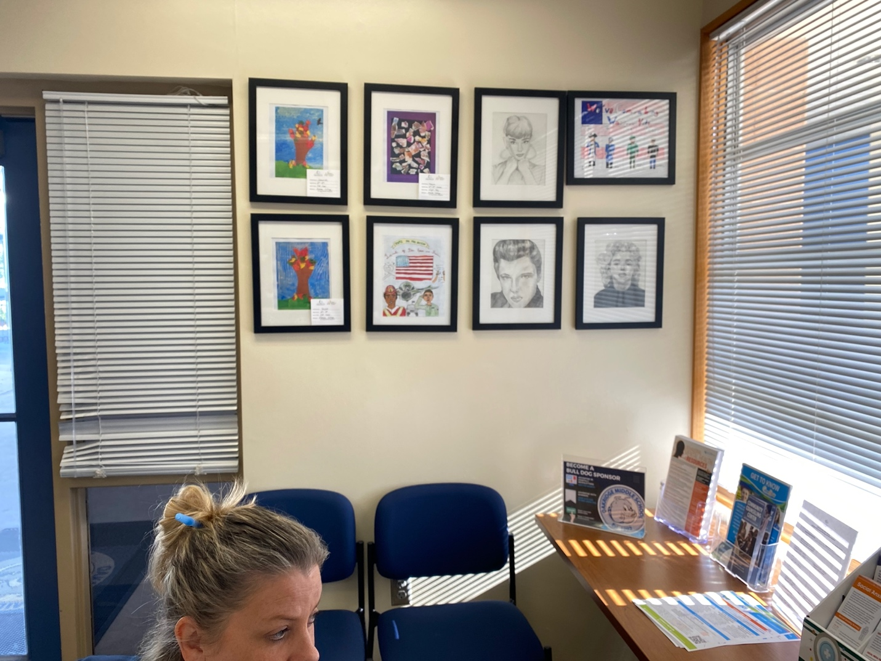Frames: