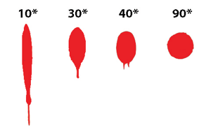
Different events cause different types of bloodstain patterns. The size, shape, distribution and location of blood stains can be used to help reconstruct events. A passive bloodstain refers to patterns created by free falling drops or a pool of blood that has been formed by the force of gravity.
Blood Spatter Analysis
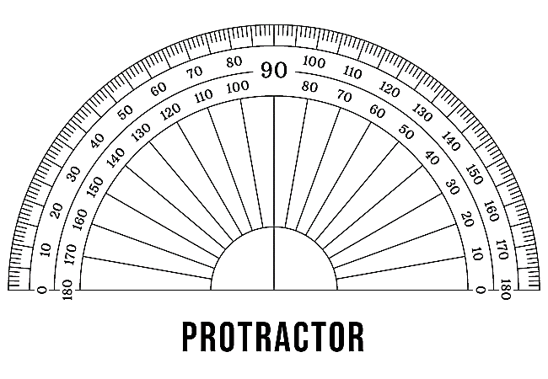
We will investigate the changes in passive and spatter blood droplets when blood falls from different heights, angles and speeds. Students will also analyze passive blood droplets that fall while walking and running. After each experiment, students will measure the length and width of each blood droplet and note any changes in size and shape.
Creating Blood Droplets
Students will use a syringe, tape measure and protractor to create passive blood droplets from various heights and angles. Students will drip blood droplets at 90° from heights of 1’, 3’, and 6’.
Creating Acute Angles
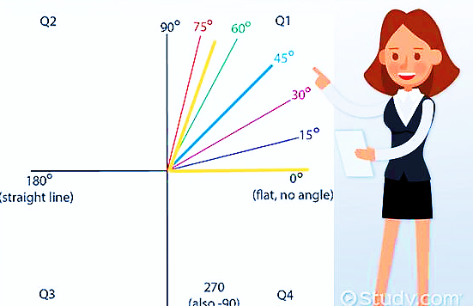
Students will use the protractor to measure angles to create blood droplets at 90°, 60°, 45°, and 10°. Students will use the syringe to push blood onto the flat surface at the angles mentioned.
Materials:
- Fake Blood
- Syringe
- Protractor
- White butcher paper
- Tape Measures
- Disposable Gloves
- Pen/Pencils

Team Names: ________________________________________________
Part 1 ________________________________________________
Step 1: Drip passive blood droplets at an angle of 90 degrees from three different heights.
Step 2: Measure and record the width and length of each droplet in millimeters.
Step 3: Draw each passive blood droplet noting the size, shape, spikes and satellites.

Angle: 90°  Height: 1 foot  Width: ________________________ mm  Length: _______________________ mm  Draw the Shape: | Angle: 90°  Height: 3 feet  Width: _____________________ mm  Length: ____________________ mm  Draw the Shape: | Angle: 90°  Height: 6 feet  Width: _____________________ mm  Length: ____________________ mm  Draw the Shape:
Part 2
Step 1: Push blood droplets through the syringe onto a flat surface at 60°, 45°, and 10°.
Step 2: Measure and record the width and length of several droplets in millimeters.
Step 3: Draw the passive blood droplets noting the size, shape, spikes and satellites.

Angle: 60°  Width: ________________________ mm  Length: _______________________ mm  Draw the Shape: | Angle: 45°  Width: _______________________ mm  Length: ______________________ mm  Draw the Shape: | Angle: 10°  Width: ______________________ mm  Length: _____________________ mm  Draw the Shape:
Part 3

Step 1: Drip passive droplets onto a flat surface as you are walking and running a short distance.
Step 2: Measure and record the width and length of the droplets in millimeters.
Step 3: Describe the passive droplets for each activity noting the shape, spikes and satellites.

Passive blood droplets while WALKING

Walk a distance of ten feet while allowing blood droplets to fall from the syringe onto a flat surface.

Width: __________________ mm

Length: _________________ mm

Draw the droplets noting the size, shape, spikes and satellites.

Passive blood droplets while RUNNING

Run a distance of ten feet while allowing blood droplets to fall from the syringe onto a flat surface.

Width: __________________ mm

Length: _________________ mm

Draw the droplets noting the size, shape, spikes and satellites.

Team Assignments

Blood Dropper: _____________________________________________

Recorder/Drawer:___________________________________________

Droplet Measurer: _________________________________________

Angle Measurer: ___________________________________________

All Team Members are responsible for their own supplies including:

Tape measure
Protractor
Syringe
Pen/Pencil
White paper for 90°, 60°, 45°, and 10° droplets.
White sheet of paper for Walking and Running droplets.
Disposable gloves

