Name: __________________________________________________ Date: _____________ Period: ____
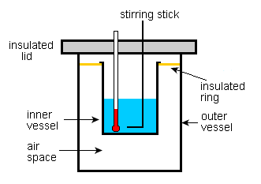
Calorimetry, ENERGY and Artisan Soap QUIZ!

Matching:
1. _______ Joule a. a system releases energy to the surroundings
2. _______ calorie b. form of energy that transfers from moving particles
3. _______ enthalpy c. change in heat of a system
4. _______ heat d. a system absorbs energy from the surroundings
5. _______ exothermic e. SI unit for energy
6. _______ endothermic f. amount of energy required to raise the temp of 1 g of water1 ° C.

Fill-in: Endothermic decomposed release chemical change
Absorbed required exothermic physical change
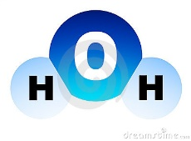
7. A chemical reaction that involves the breaking of bonds is considered an ______________________ 8. reaction because energy is __________________. For example if a water molecule is
9-10. ________________________ into hydrogen and oxygen, energy is ___________________ . If oxygen and hydrogen are bonded together to form water, this bond formation would
11-12. ________________ energy and is considered ___________________. Both reactions create new
13. Substances as products and represent a ______________________________________________.
True / False:
14. ____________________ The kilocalorie (C) is the unit used to calculate energy in food.
15. ____________________ Liquids with high vapor pressures have weak intermolecular interactions and low b.p.
16. ____________________ Heat of fusion is the amount of heat required for dissolving 1 mole of solute.
17. ____________________ Temperature is a measure of the average kinetic energy of the particles.
18. ____________________ Heat of fusion and heat of solidification have the same value but opposite signs.

19. Which has a higher specific heat, water or iron?
20. Extended Response (Explain):

Calculations: q = C * m * T specific heat capacity of water = 4.184 J/g C or 1 cal/g C
q = heat C = specific heat capacity T = change in temperature
21. How many joules are needed to warm 25 grams of water from 25° C to 50° C? (show work for credit)

22-23. One Cheetoh was burned under a canister of 100 ml of water and the temperature of the water went from 22.0 to 26.12 °C. How much heat in calories did the Cheetoh contain?
(show work for credit)

Use graph to answer#24-25.
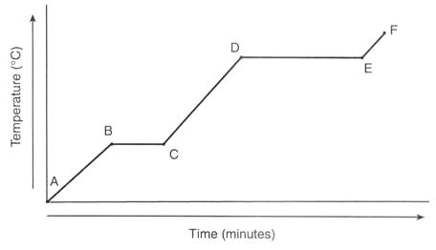
24. Where does melting occur?
- D to C b. A to B c. B to C d. not on this graph
25. Where does solidification occur?
a. D to E b. C to B c. A to B d. E to D

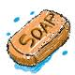
26-30. Fill in the blanks and answer the written question in complete sentences. The answers appear in red print below for people reading this to learn about the success of these laboratory experiments.
Melting coconut oil and palm oil to make artisan soap involves a phase or physical change which is endothermic because it absorbs heat. Dissolving lye or sodium hydroxide in ice and water involves a phase or physical change and is exothermic because it releases heat. When the lye solution and melted fats are mixed together a chemical change occurs called saponification. This process makes soap which can be unmolded and sliced into bars of soap 24-72 hours later but the soap needs to cure for 3-6 more weeks. Why? Explain using complete sentences. The soap needs to dry and harden so it does not dissolve into a gloppy mess when used in at the sink or in the shower or tub. But more importantly, the soap needs to cure – or finish reacting so that no lye is left unreacted in the bar. We superfatted the soap but it still needs 3-6 weeks to make sure all the lye has a chance to completely react.

