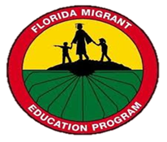

Spring Migrant Senior Event
IHS MIGRANT CENTER
2/14/24
11:15-2:00
Goal: To inform and prepare college bound migrant seniors for life after high school.

11:15-12:00 Lunch
12:00-12:30 Maria Plata, IHS Migrant Alumni
The truth about leaving home and starting a new journey
12:35-1:05 Nay Arias, FGCU, Sr. Director, First Year Experience
You are the first….
1:10-1:40 Dr. Rosado, Director of Clinical Research for the FSU Center for Child Stress and Health
How to adjust to a new environment
1:45-2:00 Q & A with presenters

