1 Book, 1 School, 1 Super Community!
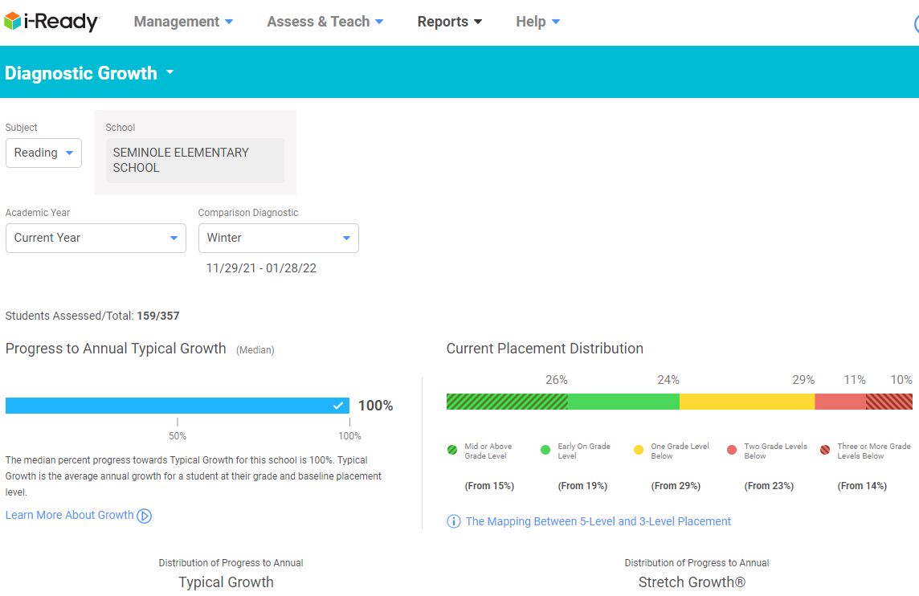
3-5 Grant Impact Data
Fall to Winter Reading Diagnostic Growth
3rd, 4th & 5th Grade Students
% scoring mid or above grade level grew by 11%
% scoring early on grade level grew by 5%
% scoring two grade levels below decreased by 12%
% scoring three or more grade levels below decreased by 4%

