Superintendent of Schools
Addison G. Davis

Principal
Frank Diaz

Assistant Principals
David Daigle
Anita Roberts

S.T.E.M Webb Middle Representative
Natalia Sutton

School Board
Lynn L. Gray, Chair
Stacy A. Hahn, Ph.D., Vice Chair
Nadia T. Combs
Karen Perez
Melissa Snively
Jessica Vaughn
Henry “Shake” Washington

July 27, 2016

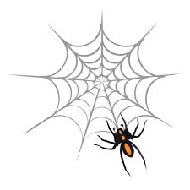
Webb Middle School

Sincerely, Mrs. Sutton
PBIS/ 7th Grade Math teacher.
Web To the donors of the Hillsborough Education Foundation
Webb Middle School wants to thank your organization for the generous donation of $2,000 to our school’s PBIS team. The funds so far have been allocated for the purchase of goods and snacks the students can purchase at the spider store with our electronic spider dollars system. They enjoy a treat every Friday and the ability to go to the spider Den every Wednesday and Friday at our school.
We have organized two dances at our school and your donation paid for the DJ and some decoration materials the students use to create the photo booth background area. We have also purchased wireless headphones as incentives to earn or purchase at the spider store. THe PBIS Ambassadors receive programs shirts to show school spirit and promotoe our PBIA Ambassador program. We have also completed two A-team/PBIS Celebrations with our students, honoring our commitment to recognized hard working students that mey not always have high achieving grades. The students at Webb Middle have benefited from your donation and your support. This money has been invaluable for the survival of PBIS program at our school.
b Middle School

