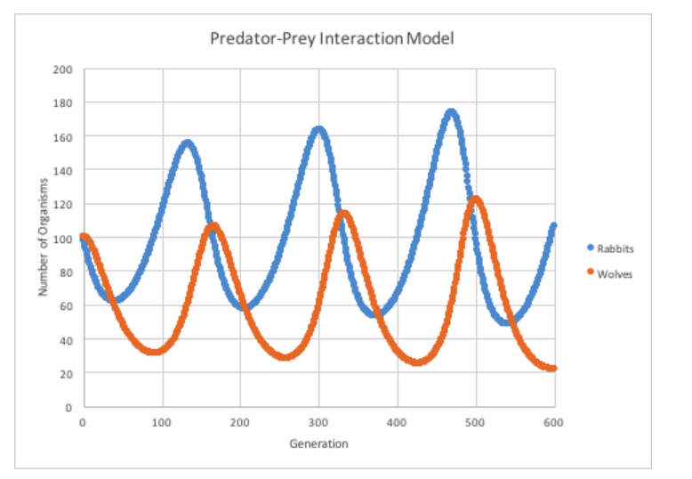
NICHE 2

- What was the rabbit population at generation 300? ___ ___ ___

3
2
1

- The wolf population increases (before / at the same time as / after) the rabbit population increases.

- Wolves are a natural predator of rabbits. The size of the rabbit population influences the size of the wolf population. Which best describes the relationship between predator and prey populations?

  - Decreases in prey population support increases in predator population.
  - Increases in prey population support increases in predator population.
  - Increases in prey population cause decreases in predator population.
  - Prey population size has no effect on predator population size.

