**OSMOSIS**

**Osmosis** = the diffusion of water across a selectively permeable membrane.

Figures A, B and C below show the effects of osmosis on animal and plant cells that were placed into 3 different types of solutions.

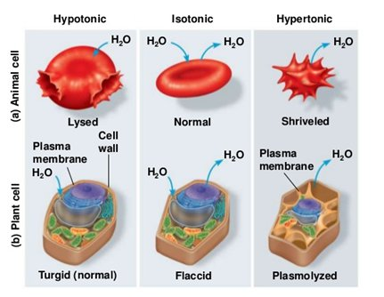

**Normal**

**Shriveled**

**Burst**

**A**

**B**

**C**

The fluid surrounding the cells in figure A is:

1. Hypertonic
2. Hypotonic
3. Isotonic

The fluid surrounding the cells in figure C is:

1. Hypertonic
2. Hypotonic
3. Isotonic

Looking at figure C, why does the animal cell burst when placed in this solution, but the plant cell does not?

1. The animal cell loses more water than the plant cell.
2. The plant cell does not gain water in this situation.
3. The plant cell has a cell wall that prevents it from bursting
4. The animal cell has a cell wall that promotes bursting.

The cells in an animal are surrounded by a layer of water and dissolved substances. For animal cells to function normally, there should be equal amounts of water moving into and out of the cell, as shown in figure B. Which type of surrounding fluid would result in equal amounts of water moving into and out of an animal cell?

1. Hypertonic
2. Hypotonic
3. Isotonic

A plant cell is placed in a hypertonic solution for 30 minutes, then removed from that solution, rinsed, and placed in the solution shown in Figure B. What would happen to the plant cell after it is placed into the second solution?

1. The cell would take on water until it reaches equilibrium
2. The cell would lose more water and die
3. The cell would take on water until it bursts
4. The cell would not change