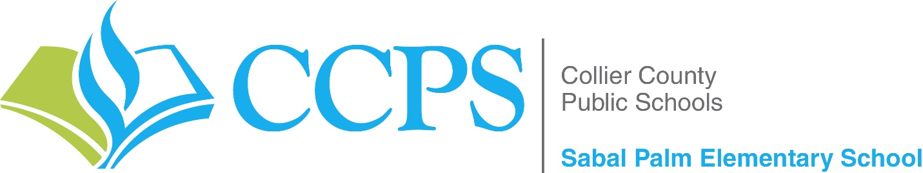

March 2026

Dear Investor,

Thank you for funding the “School Counseling Essentials” grant submitted by me, Jamie Flatley, School Counselor at Sabal Palm Elementary School. Your generosity has allowed us to purchase materials that are already making a meaningful impact on our students and school community.

These resources help students strengthen their social and emotional skills while building empathy, kindness, life skills, perseverance, and a greater sense of belonging on our campus. Through engaging activities and lessons, students are learning valuable life skills and developing the confidence to grow as leaders.

Your support is making a lasting difference in the lives of our students, and we are truly grateful.

Thank you again for funding this grant for Sabal Palm Elementary School!

Kind regards,
Jamie Flatley
School Counselor
Sabal Palm Elementary School
(239) 377 8200
flatlj@collierschools.com

