
ELEVATE Leadership Program

Small Group Meetings (Thursday/Friday – 7:00 – 7:30 AM)
Students may choose Thursday or Friday sessions but must attend at least one.
Meetings will take place in Portable 4.
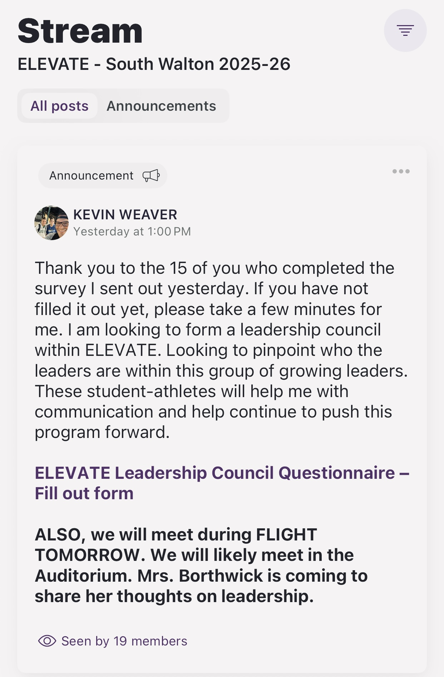
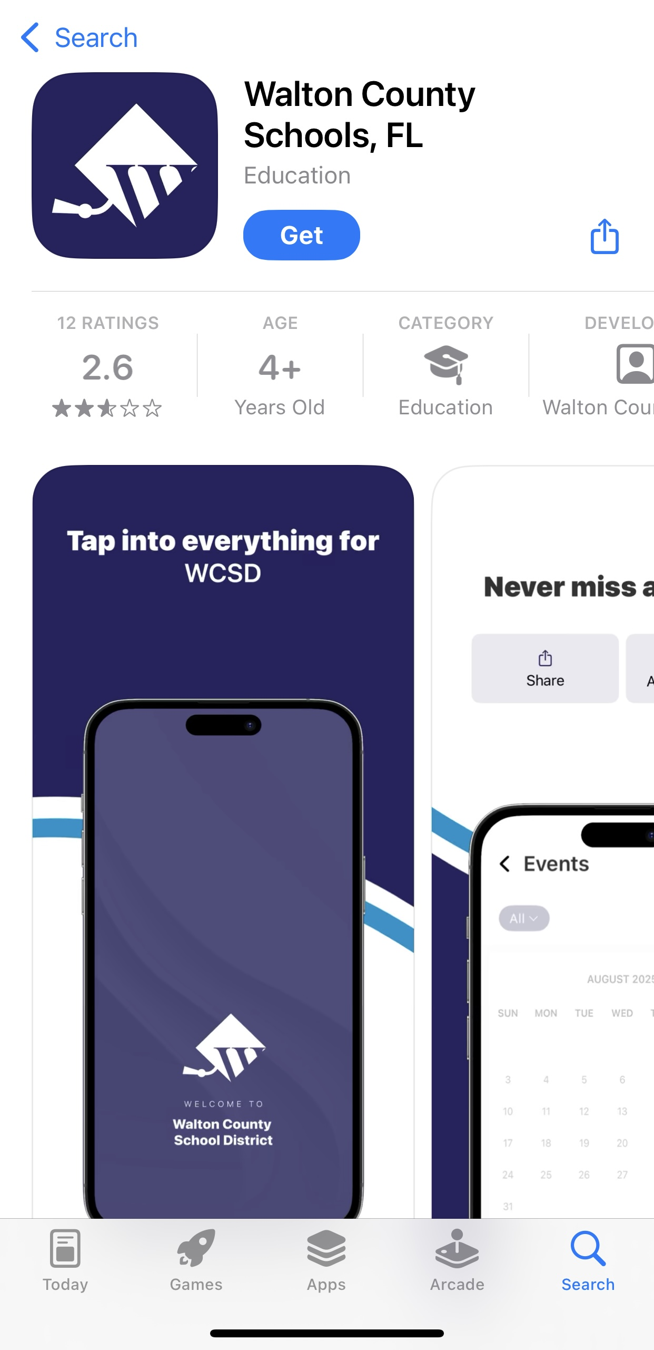
- Thursday, October 2
- Friday, October 3

- Thursday, October 16
- Friday, October 17

- Thursday, November 13
Are you using ROOMS? If not, download the WCSD app now, so you start receiving the messages. This is my primary form of communication with you.
- Friday, November 14

- Friday, November 21

- Thursday, December 4
- Friday, December 5

Full-Group Meetings (Flight Period, 10:27 – 10:44 AM)
Bringing everyone together for visibility, shared lessons, and guest speakers.
We will meet in the Auditorium on these days. (When available)
- Friday, October 3
- Friday, October 17 – Guest Speaker
  - Coach KJ Beavers – Football/Wresting coach at SW. 18 years of leadership in Special Forces
- Tuesday, November 4 – Guest Speaker
  - Mrs. Borthwick – Principal, Head Coach’s wife, Mother of student-athletes
- Friday, November 14 – Guest Speaker
  - Will Rieben – father to Annie. 7 years of active duty (Air Force), now a Colonel in USAF Reserves, 15 years of contract work overseas with around 1,000 combat operations
- Friday, November 21 – Guest Speaker (Virtual)
  - Brian Polian – AD at John Carroll Univ. Former football assistant at LSU, Notre Dame. Former head football coach at Nevada. Son of Hall of Famer Bill Polian
- Thursday, December 11 - Guest Speaker (TBD)

